A Hybrid ResNet50-ViT Architecture for Efficient Pneumonia Detection from Chest X-Ray Images
Le Hoang Anh¹, Do Thi Phuong², Tran Thi Khanh Huyen³, Le Hoang Lan⁴, Nguyen Thi Phuong Thuy⁵
¹ International School, Vietnam National University, Hanoi
hoanganhle0320@gmail.com
² International School, Vietnam National University, Hanoi
23070615@vnu.edu.vn
³ International School, Vietnam National University, Hanoi
23070496@vnu.edu.vn
⁴ International School, Vietnam National University, Hanoi
23070634@vnu.edu.vn
⁵ International School, Vietnam National University, Hanoi
23071277@vnu.edu.vn
Abstract. In recent years, the application of artificial intelligence in healthcare has emerged as a pivotal solution for alleviating the burden on medical systems and minimizing clinical diagnostic errors. Among diagnostic modalities, chest X-ray analysis is a widely utilized screening tool for pneumonia due to its cost-effectiveness and high accessibility. This paper proposes and develops an automated chest X-ray image classification system to support pneumonia detection based on state-of-the-art deep learning architectures. The study was conducted on a dataset comprising 5,857 chest X-ray images, evaluating three representative models: AlexNet, ResNet50, and a hybrid architecture combining ResNet50 with the Vision Transformer (ViT). Experimental results indicate that the baseline AlexNet model achieves an impressive Recall of 95.64%, though it suffers from a high false alarm rate. To address this limitation, we implemented an enhancement by integrating the local feature extraction capabilities of ResNet50 with the global self-attention mechanism of the Vision Transformer. The Hybrid model optimizes operational efficiency, processing 1.7 times faster than the original ResNet50 (averaging 219.67 ms/image). Furthermore, the research team developed a web-based demo application utilizing Gradio technology, enabling image uploads and visualization of suspected pathological regions with intuitive diagnostic results, thereby enhancing its practical applicability for preliminary screening. The findings of this study possess significant potential for integration into Smart Hospital Information Systems to support physicians in faster and more efficient early-stage diagnostic processes
Keywords: Medical Image Classification, Pneumonia Detection, Chest X-ray, Deep Learning, Convolutional Neural Networks (CNN), Vision Transformer (ViT), Hybrid Architecture

- Introduction
The advancement of Artificial Intelligence has led to significant breakthroughs in the field of medical image analysis, particularly in Computer-Aided Diagnosis (CAD). Among various medical imaging modalities, chest X-ray (CXR) is the most widely utilized tool due to its cost-effectiveness and high accessibility. However, the interpretation of X-ray images requires high-level expertise and can be influenced by inter-observer variability among physicians, hospital overcrowding, or human resource constraints. The application of Deep Learning techniques within the field of Computer Science to healthcare not only automates the feature extraction process but also provides faster and more accurate pathological screening capabilities compared to traditional methods [1], [2].

In recent years, numerous studies have applied Convolutional Neural Network (CNN) architectures to medical image classification tasks. AlexNet [3] inaugurated the era of deep learning in large-scale image recognition, while ResNet [4] introduced the residual learning mechanism, enabling the training of extremely deep networks without encountering the gradient degradation problem. Notably, Rajpurkar et al. proposed CheXNet, which achieved performance comparable to radiologists using the DenseNet architecture [5]. Similarly, Kermany et al. applied CNNs to medical image classification and achieved high accuracy across various pathologies [6]. Recently, Transformer architectures such as ViT [7], DeiT [8], and Swin Transformer [9] have opened new avenues by modeling the global context of images. A common characteristic of these studies is their focus on optimizing network architectures to improve overall accuracy. However, a significant limitation remains: individual models often fail to achieve an optimal balance between Precision and Recall - a critical factor in medical diagnosis. Furthermore, most existing publications remain at the experimental stage and have yet to be developed into practical WebApp applications for end-users.

To address these limitations, in this paper, we conduct research on the public 'Chest X-Ray Images (Pneumonia)' dataset from the Kaggle platform, which comprises 5,857 chest X-ray images collected from pediatric patients at Guangzhou Women and Children’s Medical Center, China. This dataset has been clinically verified by experts to ensure diagnostic reliability and labeling accuracy. To address the problem, we implemented the system using the Python language in a Google Colab environment, leveraging the TensorFlow/Keras libraries and hardware acceleration via a Tesla T4 GPU.

To improve generalization and minimize overfitting, the training process was rigorously executed with image preprocessing and data augmentation techniques. Specifically, for models such as ResNet50, we applied a fine-tuning strategy by unfreezing the final convolutional layers in combination with a flexible Learning Rate Scheduler. This approach allows the model to better adapt to the specific features of medical imagery rather than relying exclusively on generalized weights.
Experimental results demonstrate that the Hybrid ResNet50–ViT model achieves an optimal balance between Accuracy and critical metrics such as Precision and Recall. Notably, this hybrid architecture optimizes operational performance with a processing speed 1.7 times faster than the traditional ResNet50 model, averaging 219.67 ms per image. Finally, we realized this research as an intuitive web application based on Gradio technology, allowing users to upload X-ray images and receive diagnostic predictions alongside highlighted regions of suspected lesions, demonstrating the practical applicability of the model in a clinical environment.

The primary contributions of this paper include:
- Performing a comprehensive comparative analysis between traditional CNN architectures and CNN–Transformer hybrid models in chest X-ray image classification.
- Proposing a Hybrid architecture that simultaneously exploits local features and global context to improve the balance between key evaluation metrics (Precision, Recall, F1-score).
- Developing and validating a prototype system (WebApp), asserting the feasibility of the model within a practical diagnostic imaging support context, contributing to reduced preliminary screening times
- Methodology
  - Background
The dataset is categorized into two classes, including 1,583 NORMAL images and 4,274 PNEUMONIA images, revealing a significant class imbalance where approximately 73% of the samples belong to the pneumonia class.
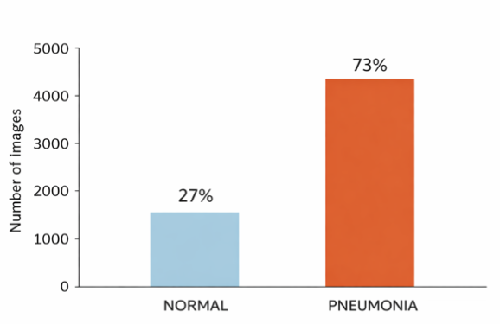
Fig. 1. Distribution of images across classes, illustrating significant class imbalance

In addition, the images exhibit heterogeneous spatial resolutions ranging from approximately 400×400 to over 2,500×2,500 pixels. Since all images are grayscale, standardized preprocessing is required before model training, which includes resizing images to 224×224 or 227x227 pixels, applying intensity normalization using 1/255 scaling, and converting grayscale images to RGB channels to ensure compatibility with pretrained convolutional neural network backbones. To ensure reliable model evaluation and prevent information leakage, a stratified data splitting strategy is adopted in which 80% of the data is allocated for training and 20% for validation, preserving class distribution across subsets and supporting stable hyperparameter tuning while maintaining generalization performance.
  - Deep Learning architecture
In this study, we investigated three distinct deep learning architectures to evaluate performance trade-offs between standard CNNs, transfer learning approaches, and Hybrid Transformer models

a. AlexNet - Baseline CNN
AlexNet was implemented as a sequential architecture consisting of eight deep layers, serving as the project's baseline to establish a benchmark for evaluating more advanced models. The architecture features five convolutional layers with a progressively increasing filter depth of 96, 256, 384, 384, and 256. This specific design enables hierarchical feature extraction, allowing the network to move from identifying low-level edges to higher-level texture patterns within chest X-ray imagery [3]
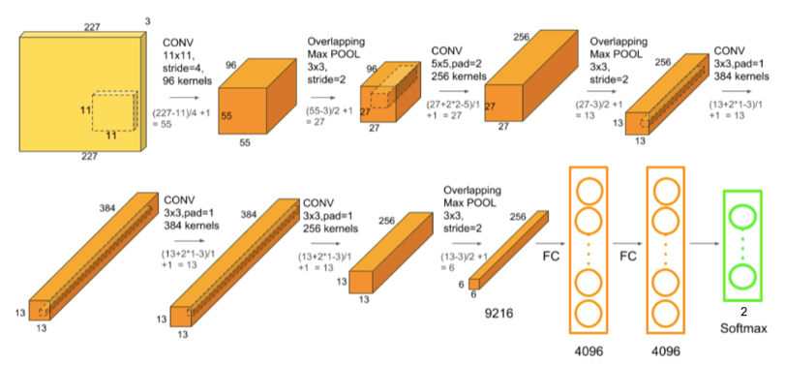
Fig. 2. Overall architecture of the AlexNet model used as the baseline CNN
A core technical highlight is the progressive feature abstraction strategy. The first convolutional layer employs a large 11 by 11 kernel with a stride of 4 to create a wide receptive field right at the network's entry. This large kernel captures coarse-grained anatomical landmarks such as lung contours, diaphragm curvature, and rib cage boundaries, effectively establishing a structural skeleton for the image.Subsequent layers transition to smaller 5 by 5 and 3 by 3 kernels, marking a critical change in focus from defining where the lungs are to analyzing what is inside them. These smaller kernels act as sensitive texture extractors that learn to identify subtle localized disruptions in the lung parenchyma, such as opacities and blurred structures, which larger kernels might overlook.
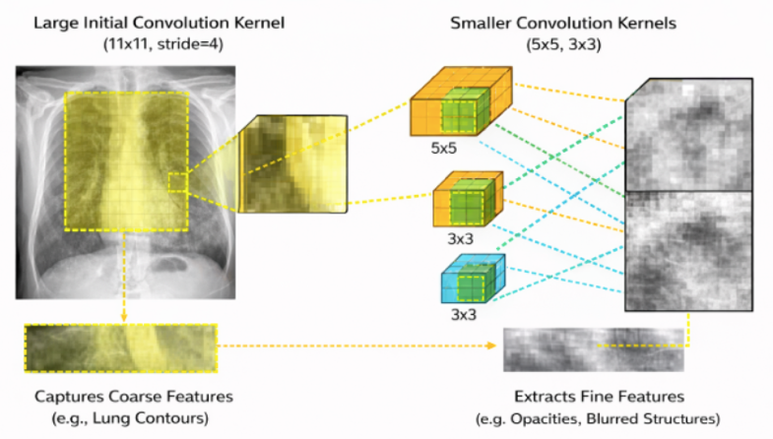
Fig. 3. Progressive Feature Abstraction strategy
To manage the high capacity of approximately 58.29 million parameters and prevent overfitting, the architecture incorporates several regularization techniques. Batch normalization layers are inserted after major convolutional blocks to stabilize gradient flow and accelerate convergence. Additionally, the model includes three high-capacity fully connected layers with dropout applied at a rate of 0.5 to enhance generalization and prevent the memorization of training data. For practical execution, the model accepts chest X-ray images resized to a fixed input shape of 227 by 227 pixels. Three overlapping max-pooling layers are strategically placed to reduce spatial resolution while retaining salient features. The final layer is a sigmoid output layer that produces a probability score representing the likelihood of pneumonia, allowing the theoretical architecture to function as an executable diagnostic tool.

b. ResNet50
In this study, we also employed a Transfer Learning approach utilizing the ResNet50 architecture [4][6], pre-trained on ImageNet, as the backbone feature extractor. To address the domain discrepancy between single-channel grayscale X-rays and the three-channel RGB input expected by ResNet50, we incorporated a Lambda layer to replicate the grayscale channel across three dimensions
Regarding the detailed architecture, the model is designed to accept input tensors of shape 224×224×3, where the convolutional base was initialized with ImageNet weights and kept frozen to preserve learned visual representations, thereby reducing computational costs and preventing overfitting on the limited medical dataset. The original fully connected layers were replaced with a custom classification head comprising a GlobalAveragePooling2D layer to aggregate spatial features and reduce dimensionality, followed by a Dense layer with 512 units using ReLU activation to capture non-linear semantic features. Finally, a Dropout layer with a rate of 0.5 is applied as a regularizer to improve model generalization, concluding with a single-unit Output layer using Sigmoid activation for binary classification between Normal and Pneumonia cases
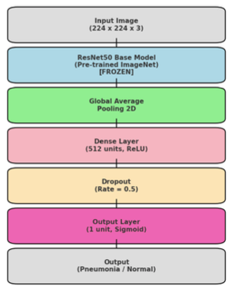
Fig. 4. Proposed ResNet50 Architecture Diagram
c. Hybrid ResNet50 + Vision Transformer
To integrate robust local feature extraction with global contextual reasoning, a Hybrid ResNet50–Vision Transformer (ViT) architecture was proposed.

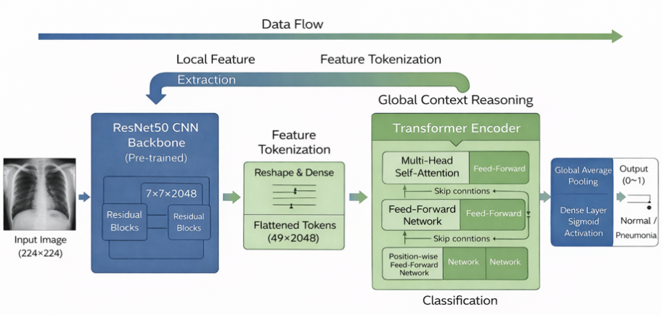
Fig. 5. Overall architecture of the proposed Hybrid model
The model preserves the inductive bias and efficiency of convolutional neural networks while enhancing global dependency modeling through self-attention. A pretrained ResNet50 backbone (ImageNet weights) is used as a frozen feature extractor to reduce overfitting on the relatively small chest X-ray dataset. For an input size of 224×224×3, the backbone produces a 7×7×2048 feature map.
Rather than applying Global Average Pooling directly, the feature map is reshaped into 49 tokens (7×7), each representing a 2048-dimensional vector. A Dense projection layer maps these features into a Transformer-compatible embedding space, and learnable positional embeddings are added to retain spatial information.
Global reasoning is performed using a lightweight Transformer encoder with Multi-Head Self-Attention (8 heads), followed by a position-wise Feed-Forward Network with residual (skip) connections, enabling modeling of long-range relationships between lung regions. The output sequence is aggregated via GlobalAveragePooling1D and passed through a classification head consisting of a Dense layer, Dropout, and a Sigmoid output neuron for binary classification [7][10]
This hybrid architecture enables joint learning of local features and global contextual dependencies while maintaining computational efficiency compared to full Vision Transformer models
  - Training Strategy and Hyperparameter Tuning
The training process was designed to ensure consistency, fairness, and direct comparability among the three model architectures investigated in this study. Although all three models address the same binary classification task on chest X-ray images (NORMAL vs. PNEUMONIA), the training hyperparameters were not rigidly fixed. Instead, they were flexibly adjusted according to the architectural complexity and computational requirements of each model, strictly following the actual configurations implemented in the source code.
Table 1. Training Configuration
Model | Batch Size | Learning Rate | Loss Function | Optimizer
AlexNet | 32 | 0.001 | Binary Cross-Entropy | Adam
ResNet50 | 16 | 0.001 | Binary Cross-Entropy | Adam
ResNet50 + ViT | 8 | 0.0001 (1e-4) | Binary Cross-Entropy | Adam

- Results
  - Quantitative Performance Analysis
Table 2. Performance table of models
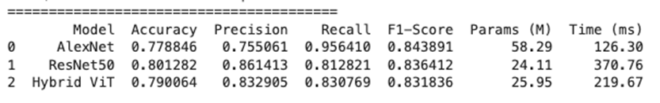
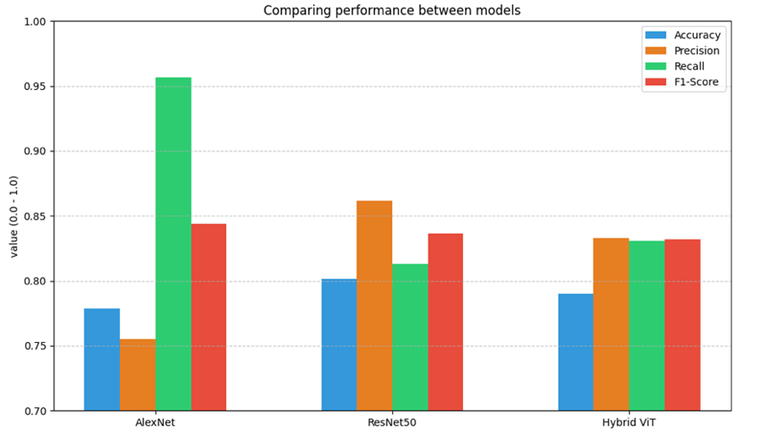
Fig. 6. Overall architecture of the proposed Hybrid model
From the graph, we can see that AlexNet recall is high but has poor precision (precision = 0.76), ResNet50 precision is good but has the slowest processing speed (recall = 0.81) and has a high potential risk of missing diseases. The Hybrid ViT achieves the most balanced results, despite having the same parameter size as the ResNet50 (~25M parameters), the Hybrid ViT has an average processing time of only 219.67 ms/image, optimizing the speed about 1.7 times faster than the ResNet50 (219ms vs. 370ms) thanks to the Attention mechanism that replaces deep convolutional layers and achieves a harmonious balance between Recall ( 83.07%) and Accuracy (83.29%), minimizing the risk of missed cases compared to ResNet50 while reducing the rate of false alarms compared to AlexNet.

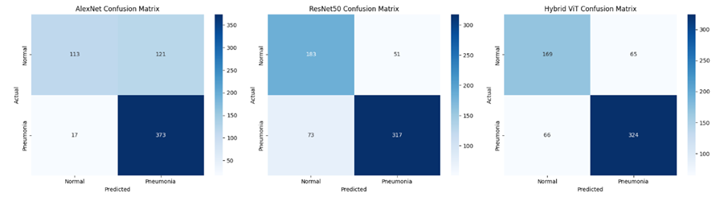
Fig. 7. Confusion matrix of three models
Compared to the ResNet50, the Hybrid model improved sensitivity by increases Recall from 81.2% to 83.0%, a 2% improvement vs ResNet50. Hybrid ViT outperformed ResNet50 in reducing False Negatives, reducing the number of missed cases from 73 to 66 cases. This proves that the Self-Attention mechanism helps to better identify faint or diffuse signs of pneumonia. Hybrid VIT is more than AlexNet in terms of resources, AlexNet has the highest F1 0.96 but a high False Positive (121), which is only suitable for initial screening.
The Hybrid ViT model achieves the best balance between medical safety, reliability, and especially superior processing speed compared to traditional Deep CNN networks. It is the most promising model for practical deployment due to its balance between accuracy and reliability, lightweight model size, and inference speed Overall, the Hybrid model optimizes medical practice thanks to its speed and balance.

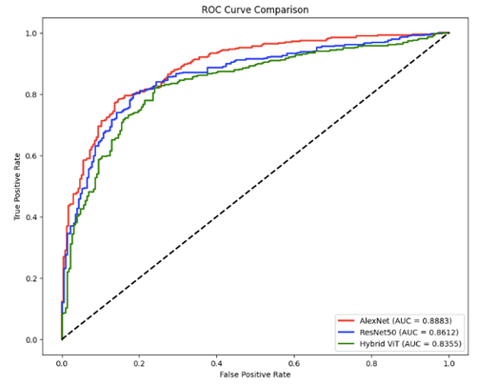
Fig. 8. Comparison of receiver performance characteristics curve
All three models exhibit good learning with convex curves towards the upper y-axis. All AUC values exceed 0.5 (random diagonal), ranging from 0.83 to 0.88. This confirms the reliability of the diagnostic system.
AlexNet AUC = 0.8883 is strong due to its superiority over small datasets, ResNet50 AUC = 0.8612, Hybrid ViT AUC = 0.8355 is weaker because ViT needs a dataset larger than the existing 5k images. Although the Hybrid has not yet reached its full potential, the accurate diagnosis of the disease is quite high, not a random prediction.
  - Web Application Deployment
To simulate the above training process, the research team deployed the Pneumo-Vision AI website on the Gradio platform. This is a classification tool that simulates the actual screening process for pneumonia from chest X-ray data. The application allows users to upload X-ray images directly from their personal devices to the web interface and receive analysis results in near time, thereby fully reflecting the operating cycle of the trained Hybrid model. Based on the set classification threshold, the system will give a prediction label of NORMAL or PNEUMONIA respectively and display it directly on the user interface.
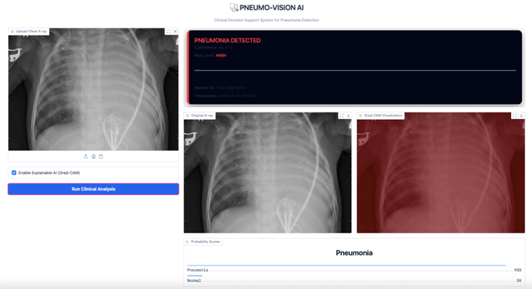
Fig. 9. Web Demo interface
After in-depth analysis using the Hybrid VIT model, the Website Demo converts quantitative results into information that supports clinical decision-making intuitively. The average processing time is only ~219.67 ms/image, basically meeting the needs of screening in hospitals. All case analysis information, including case code, lead time, predictive labels, reliability, and risk level, is compiled and exported into a written clinical report file. Users can download this report file directly from the web interface for archiving or for future reference. Based on the probability scores obtained, the app conducts a specific "risk level" hierarchy, making it easier for medical teams to prioritize emergencies during the screening process.
The demo application is a testament to the technical effectiveness of the Hybrid model, showing the potential for practical application, especially in medical environments that need to support rapid screening and reduce the workload for doctors.

- Conclusion
This study has conducted a comprehensive analysis and comparison of the applicability of deep learning architectures in automating pneumonia diagnosis from chest X-ray images. Experimental results confirm that the Hybrid ResNet50–ViT model delivers superior overall performance, achieving an optimal balance between Precision and Recall while optimizing processing speed to be 1.7 times faster than the traditional ResNet50 architecture (reaching an average of 219.67 ms/image). The successful deployment of the prototype system on a WebApp platform (Gradio) not only demonstrates the feasibility of the proposed method in practice but also provides opportunities to support medical teams in rapid pathological screening, contributing to the reduction of subjective errors in clinical diagnosis. In the future, research will focus on expanding multi-source datasets and integrating model explanation mechanisms such as Grad-CAM to enhance transparency. Additionally, the team aims to develop multi-modal learning models that combine imagery with clinical data to maximize the reliability and practical effectiveness of the system in modern medical environments.

Acknowledgement
- References
[1] G. Litjens et al., “A survey on deep learning in medical image analysis,” Medical Image Analysis, vol. 42, pp. 60–88, Dec. 2017, doi: 10.1016/j.media.2017.07.005.
[2] “Deep Learning for Medical Image Analysis,” ScienceDirect. Accessed: Feb. 13, 2026. [Online]. Available: https://www.sciencedirect.com/book/edited-volume/9780128104088/deep-learning-for-medical-image-analysis
[3] A. Krizhevsky, I. Sutskever, and G. E. Hinton, “ImageNet Classification with Deep Convolutional Neural Networks,” in Advances in Neural Information Processing Systems, Curran Associates, Inc., 2012. Accessed: Feb. 13, 2026. [Online]. Available: https://proceedings.neurips.cc/paper_files/paper/2012/hash/c399862d3b9d6b76c8436e924a68c45b-Abstract.html
[4] K. He, X. Zhang, S. Ren, and J. Sun, “Deep Residual Learning for Image Recognition,” Dec. 10, 2015, arXiv: arXiv:1512.03385. doi: 10.48550/arXiv.1512.03385.
[5] P. Rajpurkar et al., “CheXNet: Radiologist-Level Pneumonia Detection on Chest X-Rays with Deep Learning,” Dec. 25, 2017, arXiv: arXiv:1711.05225. doi: 10.48550/arXiv.1711.05225.
[6] D. S. Kermany et al., “Identifying Medical Diagnoses and Treatable Diseases by Image-Based Deep Learning,” Cell, vol. 172, no. 5, pp. 1122-1131.e9, Feb. 2018, doi: 10.1016/j.cell.2018.02.010.
[7] A. Dosovitskiy et al., “An Image is Worth 16x16 Words: Transformers for Image Recognition at Scale,” Jun. 03, 2021, arXiv: arXiv:2010.11929. doi: 10.48550/arXiv.2010.11929.
[8] H. Touvron, M. Cord, M. Douze, F. Massa, A. Sablayrolles, and H. Jégou, “Training data-efficient image transformers & distillation through attention,” Jan. 15, 2021, arXiv: arXiv:2012.12877. doi: 10.48550/arXiv.2012.12877.
[9] Z. Liu et al., “Swin Transformer: Hierarchical Vision Transformer using Shifted Windows,” Aug. 17, 2021, arXiv: arXiv:2103.14030. doi: 10.48550/arXiv.2103.14030.
[10] Y. Hadhoud et al., “From Binary to Multi-Class Classification: A Two-Step Hybrid CNN-ViT Model for Chest Disease Classification Based on X-Ray Images,” Diagnostics, vol. 14, no. 23, p. 2754, Jan. 2024, doi: 10.3390/diagnostics14232754.

